**I’ll wait for my CGA, interest rates are going up.**

**Probable donor says:** “I just heard on CNBC that interest rates are going up. I have your CGA proposal in hand but I think I will wait a little while to see if this is the right move for me.”

Lately, I am beginning to hear the above from those with good intentions but not great charitable motivation. They are concerned they will get a better deal if they postpone acting on their CGA proposal.

Let’s step back and examine if this is truly a good “strategy” waiting to make a gift.

Let’s start with the basics. As you probably know a CGA is an irrevocable agreement with the terms outlined in the signed agreement. The agreement lists both the payment amount and frequency. Quarterly are the most common frequency selected as it matches most dividend payments from securities.

There are two important aspects of a CGA. First, it is part gift and part return of capital sometime thought of as an investment. For those who itemized this deduction reduces the cost of the gift by the taxes saved. Second, gift annuities produce tax-free payments. Tax-free payments are better than taxable payments. The tax-free payment amount ends in the future when the annuitant reaches their IRS determined life expectancy. Normally this may be 10-20 years in the future.

Combining these two benefits determines the taxable equivalent yield from the CGA.

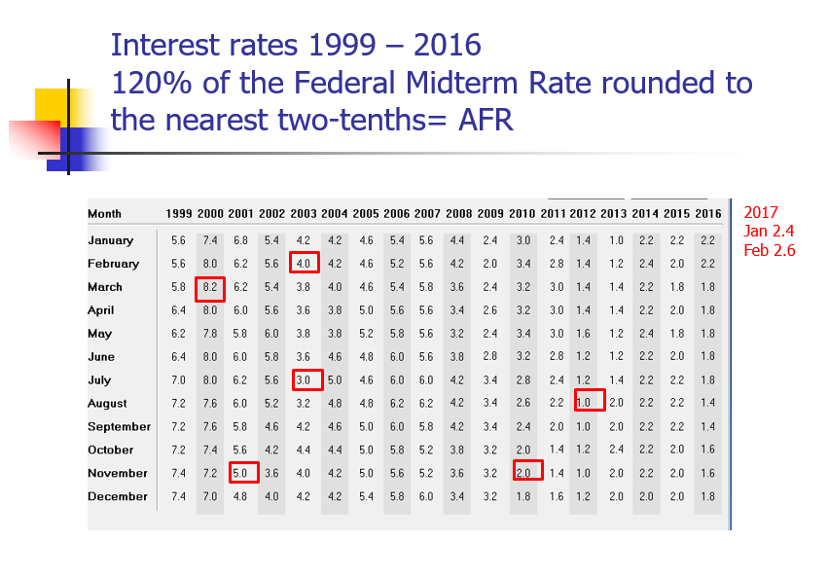**How fast do interest rates move upwards or downwards**? To examine this, take a look at interest rates from 1999 to 2016 as reflected in the monthly AFR produced by the IRS. The AFR represents 120% of the Federal Midterm Rate rounded to the nearest two-tenths. Calculated monthly it is also known as the Section7520 rate. The red boxes show some of the highs and lows from a high of 8.2% in March 2000 to a low of 1.0% in August 2012. Even if you add the current rates of 2.5% for January 2017 and 2.6% for February 2017 you are far from the early year highs.

Let’s examine two examples to show probable donors they should not wait to make their gift.

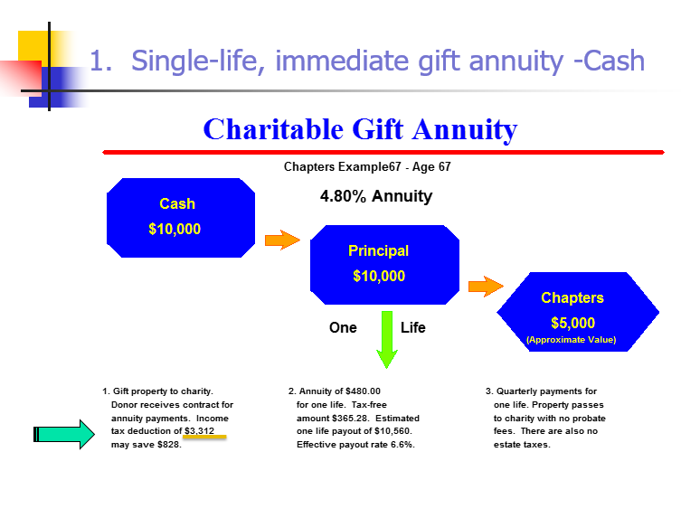First example is for Mr. Thomas age 67 who has a $10,000 revocable certificate of deposit (CD) maturing and might consider a transfer to an irrevocable CGA to increase his annual income. He could rollover his CD perhaps to a 5-year CD and receive 2.0% annually or he could consider other investment options such as a bond fund. But he wants to make a gift and a gift annuity seems like a reasonable alternative considering his financial state in life.

As you can see Mr. Thomas will receive 4.80% payment and a $3,312 charitable deduction. With $365.26 of his $480.00 annual income received tax-free until 2036 or for 19 years.

**What about interest rate increases?** To examine this question, we need to construct a simple Excel spreadsheet. I start with a base interest rate of .05% and increase that rate by .05% each year. As the below spreadsheet shows it takes 17 years for the cumulative after tax payments from the 1 year CD to equal the after tax cumulative payments from the gift annuity. Since taxes play a role with the spendable income taxes are subtracted at a 25% rate from both the CD payment and the gift annuity payment.

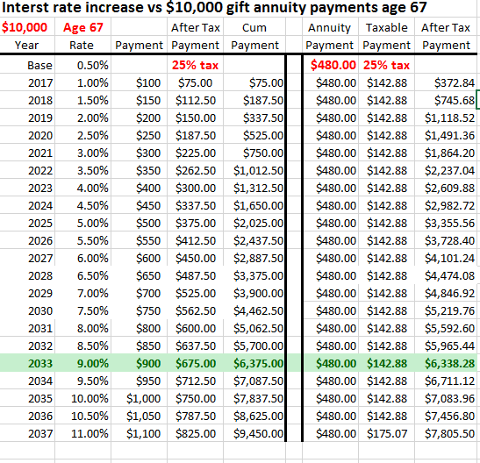

**Mr. Thomas has a decision to make. Will he play the interest rate increase possibility or settle for a stable and guaranteed lifetime income with fixed known tax-free payments. I think considering he will be age 83 when he breaks even the safe and sound decision would be to do the gift annuity.**

**How about a gift annuity funded with appreciated assets?** Does the same reasoning prevail when a portion of the payments are taxed at capital gains rates?

Let’s examine the case of Mr. and Mrs. White both age 70. They have a long term holding of several thousand share of ABC stock with a purchase price of $25,000 that is now worth $100,000. Because they are both age 70 the CGA payment would be 4.60%.

They receive a charitable deduction of $32,275 and the capital gain associated with their tax deduction amount ($24,562) is never taxed.

Of that $4,600 payment $825.04 is tax-free, $2,477.76 is capital gain and the balance ($1.297.20) is taxed at ordinary income rates.

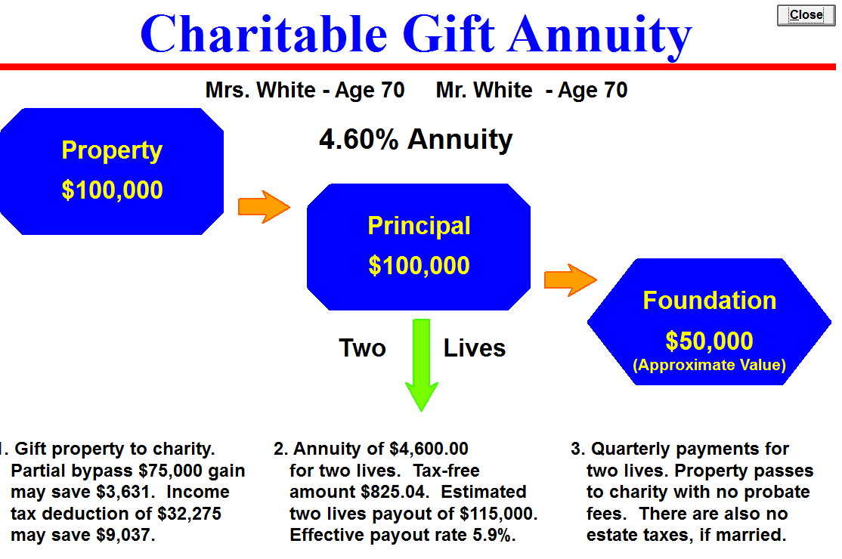

**My comparison increase interest rates at 1.00% per year and subtracts income and capital gains taxes from each CD and annuity payment. When does a CD return outpace the net spendable income from a gift annuity?**

As the below Excel spreadsheet shows when you subtract the taxes from the payment it significantly decreases the point at which a CD rate increase will outstrip the cumulative payments from a gift annuity. In our example in 10 years when the donors both will be age 80 the 1 year rollover CD beats the gift annuity.

What are the odds the one year CD rate which is currently around 1.05% will increase 1.00% per year? Well anything is possible but I don’t suspect interest rates will increase to 12+% during my lifetime so I would feel confident in suggesting to these donors the wonderful advantages of a gift annuity to support their favorite charity.

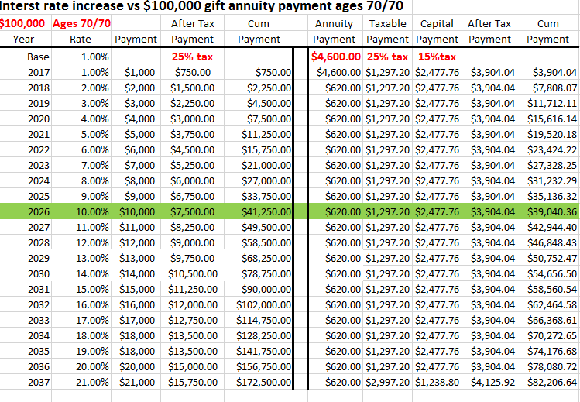

**For comments or concerns email me at** [james@connellandassoc.com](mailto:james@connellandassoc.com)

 ***JAMES E. CONNELL &ASSOCIATES***

Charitable Estate and Gift Planning Specialists

15 Pinewild Drive, P.O. Box 3335

Pinehurst, North Carolina 28374-3335

Phone 910-295-6800 ….. Fax 910-295-6866