The purpose of this document is to outline and explain the major steps to follow when you are implementing a bequest or legacy challenge campaign for your charity.
The objective of a bequest challenge is simply to garner maximum documented bequest expectancies from your current donor base while also achieving an amount of immediate cash support for your current program objectives. A legacy challenge campaign counts bequest, life income and planned gift agreements toward the challenge goal.
It is simply a matching gift program which focus on raising panned gift expectancies.
Below is a chart developed for a George Washington University (GWU) Legacy Challenge.
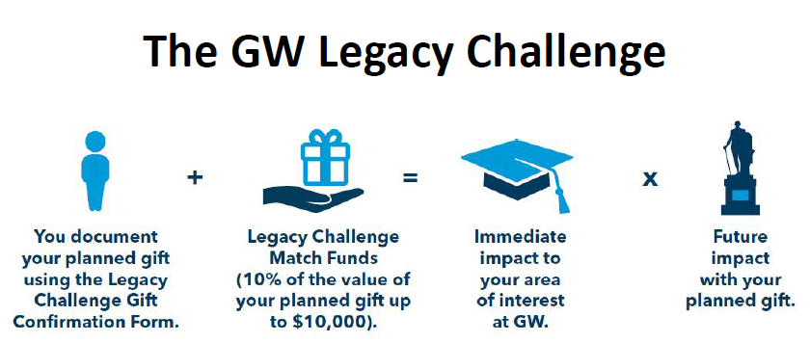
To accomplish this objective, you will need all of the components outlined below, as well as, several supporting documents and promotional communications.
- Why a legacy challenge?
  - It creates a sense of urgency for planned giving donors to document and disclose their gifts now. It inspires more giving, more participation and a higher average gift.
  - It also allows planned giving donors to provide impact today, as cash from the match goes immediately to your organization.
  - It provides and incentive for those considering a planned gift to update their plans and participate in the match.
  - It provides new donors who are stimulated by the match to establish new planned gift expectancies.
  - It consistently identifies a greater return at lower cost than the expected amount from the matching fund ratio.
    - Example: a 1:10 match with $100,000 pool would be expected to produce $1,000,000 in expectancies whereas the actual results were $3,000,000+ in future expectancies. (GWU figures)
  - The challenge is a time sensitive program similar to a capital campaign.
  - The challenge is an effective program that is repeatable in the future.
- Getting approval for the challenge
Seeking leadership approval and endorsement is an important avenue for education on the objectives of the bequest/legacy challenge. It is also an opportunity to identify donors interested in stepping up to be part of the matching pool.
The identification of those whose approval is needed will be unique to each charity. It should involve board leadership, key administrative officers and the entire advancement team.

- Finding matching donor(s)
The ideal donor(s) are already in your gift files as they are committed to your mission. They may be a modest donor who is willing to step up with a significant challenge to others or they may be a participant in a group of modest donors who would increase their annual unrestricted gifts to initiate the matching pool.
The matching pool should not be from charity assets.
The matching pool needs to be an unrestricted match. You may decide to offer challenge donors the chance to restrict their gifts to a specific program, department or initiative. Matching donors need to know their support can go anywhere as it prevents offending the match donors.
Of course, there is always the opportunity to have one donor step up and commit $100,000 or more to name the whole pool or be the first donor into the matching pool. There is no limit to the size of your pool but you want it to be significant for your first effort and to reflect the nature of your charity. A larger pool encourages greater participation.
The criteria of the match should be agreed upon before approaching potential donors as you should be as transparent as possible to all participants. Being transparent means you are off to a strong start.
- Time and dollar laminations
Time limitation is an important aspect of the bequest/legacy matching program as it creates a sense of urgency for prospects. Deadlines encourages commitments to any match donor your charity is organized to blast off with a successful effort.
The limitation may be time sensitive or dollar sensitive. Time sensitive indicated the campaign will run for a set period 4, 6, 8 or 12 months. Dollar sensitive indicate the program will end when the matching funds are all allocated. Combining these objectives, a campaign could run for “6 months or until the matching funds are all allocated.”
If the initial campaign is successful and has created significant interest in the effort, proved the low cost and significant rate of return there is no reason not to initiate another campaign at a future time.

- Samples of matching criteria are listed below
  - Mother Jones Legacy Society - a donation equal to 10% of the expected value of your future gift will be made to Mother Jones right now in your honor…up to $10,000/gift.
  - Planned Parenthood Federation of America - Planned Parenthood organization(s) you designate will receive a grant of 10% of the value of your future gift right now, up to a maximum grant of $25,000. Any anonymous amounts received a $1,000 match.
  - George Washington University – used a 10% match up to $10,000/gift cap. Provided donor designation of the legacy challenge match to existing funds only.
  - Agricultural Stewardship Association – the Association received a set amount of $500 for each bequest commitment up to a total match total of $15,000. No percentage of value matching gifts.
  - Community Foundation of Holland/Zeeland – to increase their community endowment from estate gifts, matched bequest which had a $200,000 minimum commitment amount at 5% in an estate commitment, limited to first 100 donors.
  - Heifer International – 10% up to $10,000, campaign ends December 31, 2020
  - Gallaudet University - Macfadden Legacy Challenge only for alumni, former students age 50 and older, $1,000 per planned gift, limit $25,000 total.

- Gifts that qualify for the bequest/legacy challenge

Qualifying gifts must be identified in advance. The below are examples of qualifying gifts for a bequest and legacy challenge program.
- Will or living trust which includes (charity) bequest language
- IRA or retirement account which includes a percentage distribution to (charity)
- Charitable remainder trust that includes an irrevocable percentage distribution to (charity)
- Bank accounts registered as a paid-on-death (POD) beneficiary designation
- Brokerage, or other financial account i.e. a mutual funds, registered as transferred on death (TOD) beneficiary designation
- Beneficiary designation (in whole or a percentage) of an existing life insurance policy
- New life insurance purchase where (charity) is owner and beneficiary and donor pays all premiums
6a. Gifts that qualify for the legacy challenge
- All of the above plus life income programs
  - New charitable gift annuity agreements
  - New charitable remainder trust agreements
- Permanent designation of remainder amounts of donor advised funds

- How the bequest challenge works
In simple language some of the information below may serve as structure and copy for your website explanation
The Bequest Challenge is a campaign to inspire charity supporters to make bequest commitments for the future and, in return, help us earn much-needed challenge pool dollars for use today!
Through the Bequest Challenge, you can maximize the impact of your future bequest and estate plans.
Step 1: Name (Charity) in your will or living trust or as a beneficiary of your retirement or financial account. New commitments and document previously established bequest plans.
Step 2: Download a Bequest Challenge form (here or click here to fill it out online).
Step 3: A group of longtime (charity) donors will make a gift right now to (charity) in your honor. They will donate a gift equal to 10% of the value of your future gift, up to a maximum grant of $10,000. If you would prefer to keep the estimated value of your gift private, matching donors will donate $1,000 in your honor.

- Marketing plan and pieces
You want to create attractive supporting documents and communications for your challenge program. This should include several important items.
  - Make sure your commercially produced planned gift brochures and flyers are up-to-date
  - Create a logo reflecting the challenge program opportunity
  - Develop separate letterhead for prospect and participant correspondence
  - Create a “One-Pager describing the program
  - Develop a “Bequest arrangements to charity” handout examples
  - Develop a story about each matching gift donor and the thoughts behind their participation in the program. Put donor background stories on your promotional website page.
  - Create a challenge confirmation form separate from your legacy society commitment form
  - Design a special website page to explain the program with links to planned gift explanations, challenge confirmation form and donor stories
  - Use existing planned giving marketing vehicles to explain the challenge program opportunity for participation
  - Develop a direct mail postcard promotion with links to the website page and confirmation form
  - Establish a list of your top 25 – 50 prospects to be visited

Appendix - Bequest documentation form Planned Parenthood

- 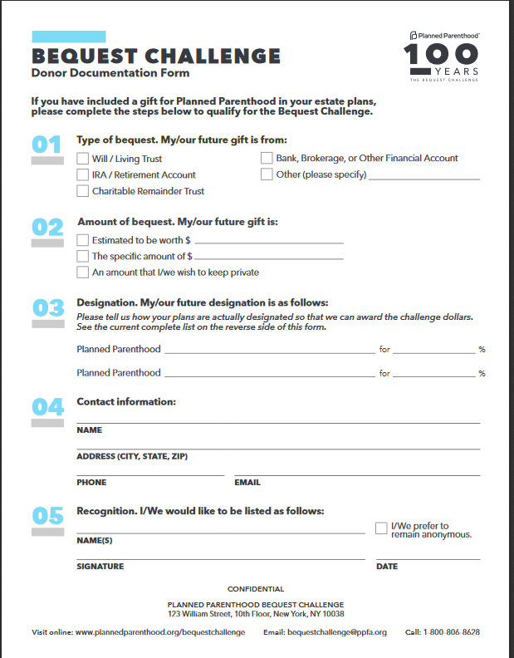

Appendix – Legacy documentation form George Washington University, page-1
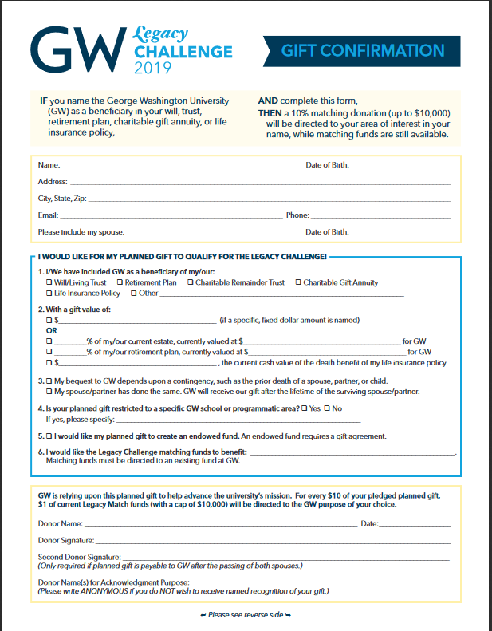

Appendix – GWU Legacy documentation form page-2
The back of the form encouraged an additional annual gift to GWU
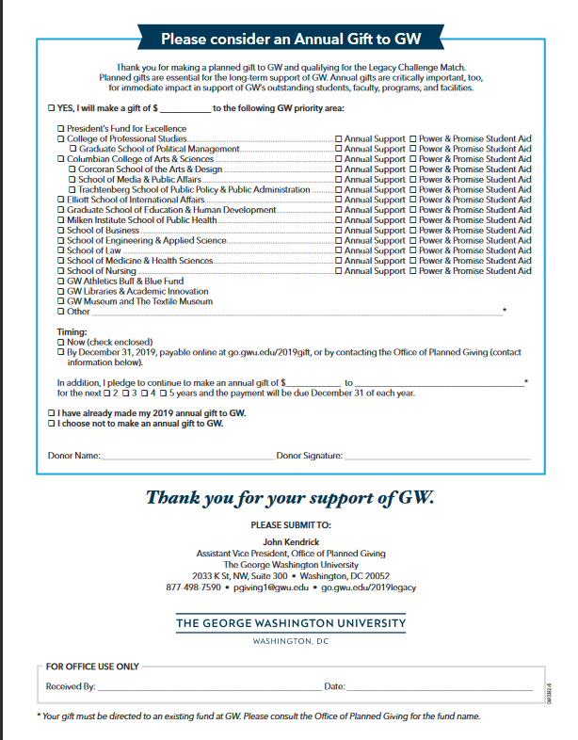
Appendix – Sample stories on matching donors
https://www.motherjones.com/support/bequests/
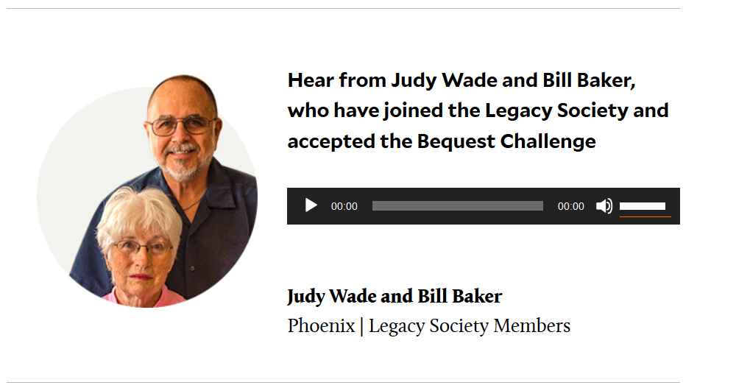
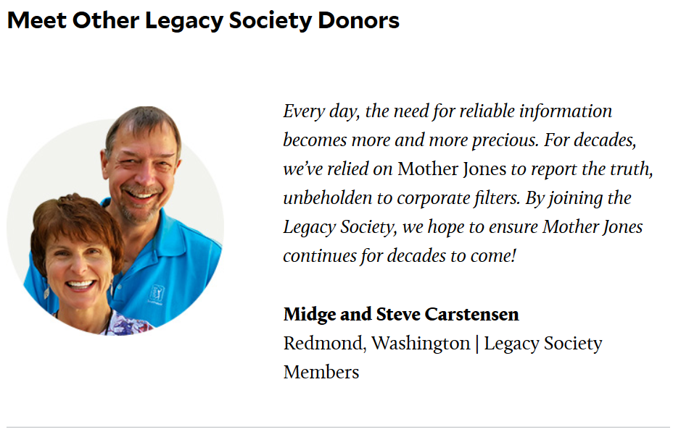
Appendix – Sample stories on matching donors
https://www.plannedparenthood.planyourlegacy.org/bequestchallenge/bequest-challenge-meet-the-funders.php
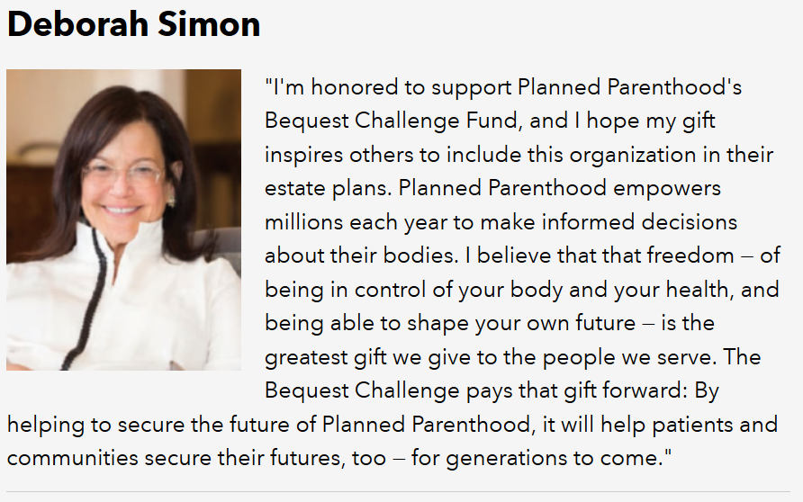
Appendix - Story from a matching gift particpant
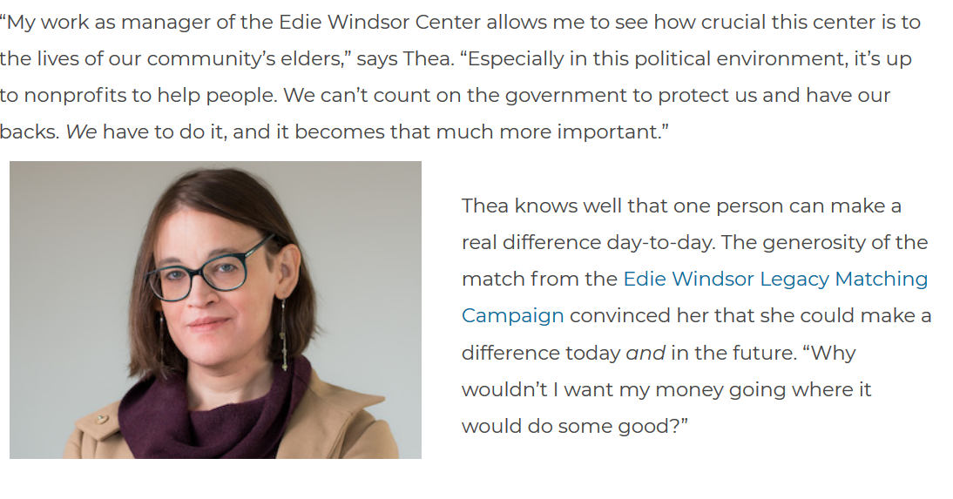
https://www.sageusa.org/thea-cook-taking-care-now-and-in-the-future/
Appendix - GWU frequently asked questions
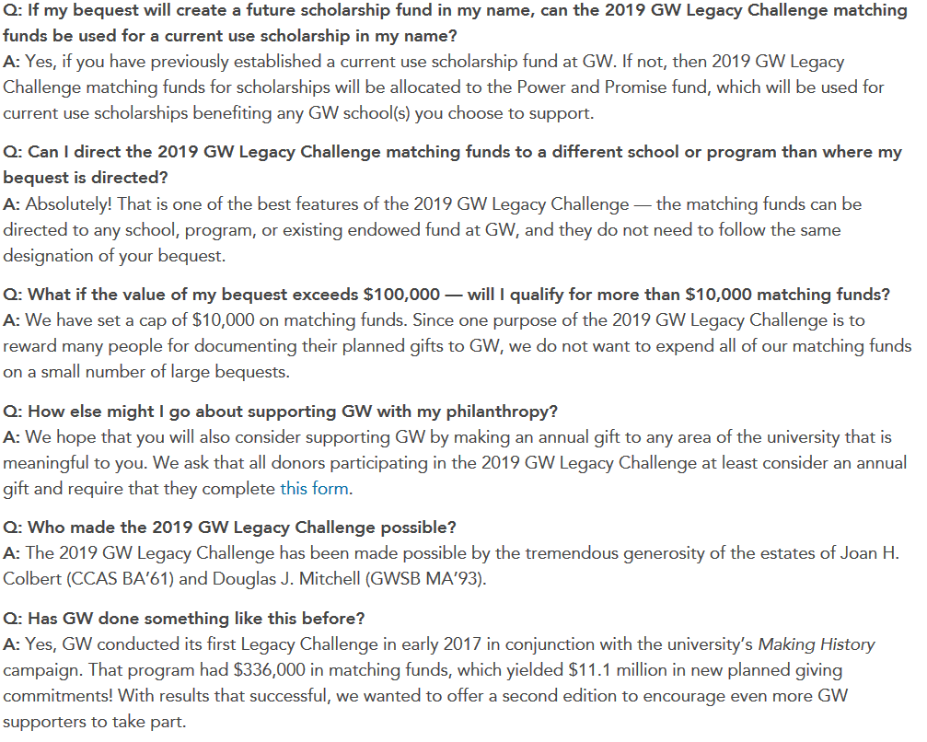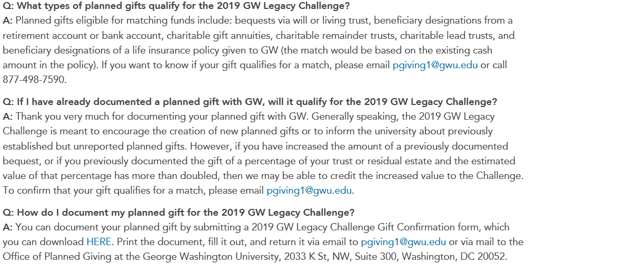

_____________________________________________________________________________
This campaign primer is being sent to you as an informational service of Connell & Associates.
For a confidential proposal on how Connell and Associates will work with your charity to start a Bequest or Legacy Challenge campaign send your contact information to the email address james@connellandassoc.com.
_____________________________________________________________________________
